L 6. Self-regulation: paradigms, self-control, emotional firewall

In the absence of self-awareness, it is very unlikely that we can move towards the development of self-regulation. If we are not aware of the emotions we experience, it would be rather challenging to regulate them. Self-regulation is the ability to manage our internal feelings, thoughts and emotions, and to abide by our individual, self-chosen value system. Self-regulation is important in handling our emotions, disappointments and failures. It is the choices we exercise as an individual. It is not about suppressing our emotions and feelings but rather managing them effectively. When we are exposed to stimulus in our daily lives, we are bound to experience emotions. The manner in which we handle our emotions is driven by self-regulation. It is also the ability to forget, forgive, ignore and postpone our responses rather than react impulsively. The real need for self-regulation comes into play when we are faced with challenging situations. The mind usually tends to choose the easier route by dispensing with emotions in the overall equation. In laymen’s term, we often use the word ‘patience’ to signify selfregulation. This is a significant component of EI, which leads to effectiveness in all walks of life.
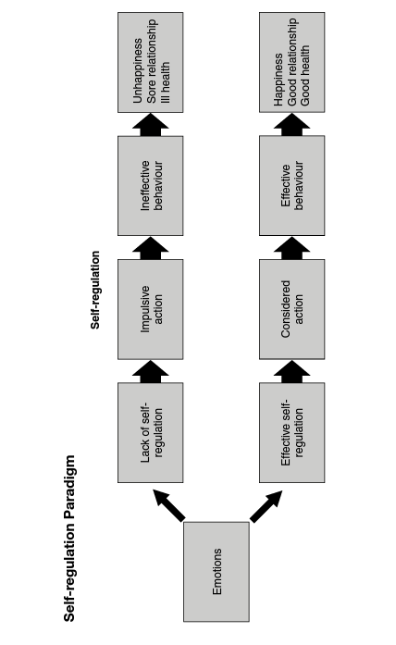
When a sportsman is engaged in a popular sport, witnessed by thousands at a stadium amid a constant deafening noise of cheering and booing from spectators, self-regulation is put to test. If distracted due to unmanaged emotions, it's literally the end of the game for the player. This applies to all walks of life, not just confined to sports.
The ability to submerge our emotions and maintain a steady focus on our goals is the essential outcome of self-regulation. It helps us to manage our thoughts, feelings and behaviour under various situations that we face in our lives.
Self-regulation has two dimensions, namely monitoring and managing emotions. Most behavioural skills are put to test when the going gets tough and things are not in our favour. When emotions take over the executive functions of the brain, they need to be managed well enough to render effective responses.
Our memory and reasoning skills are majorly dysfunctional when engulfed by emotions. Being charged with unmanaged emotions further diminishes our ability to listen effectively. When we are able to regulate our emotions and prevent impulsive actions, we are more likelv to be effective in our interactions. The other extreme response is to perennially withdraw from the situation rather than face it.
Self-regulation impacts all other components of El. It is rather important to understand that our emotions are generated within us and not outside. Hence, the mechanism to regulate them too lies within us. There is no reason to blame anyone but ourselves for our inability to regulate our emotions.
These are some of the early symptoms in children that indicate a lack of self-regulation:
- Children act 'silly' and 'out of control'
- Children throw tantrums and would not subside until they get what they want
- Struggle in transition between activities
- Have difficulty in waiting or taking turns
- Struggle with being in close proximity to others
- Grab, throw or touch things impulsively
- Display of restlessness
These early symptoms can be a wake-up call, making it important to help the child develops effective self-regulation.
ARE EMOTIONS GOOD?
Emotions left alone are not harmful. They are just signals that not only help us to communicate and connect with others but also enable us to understand ourselves better. Each trigger of emotion tells us something. What we do with our emotions is an altogether different proposition
MANAGING EMOTIONS
Adarsh faced a lot of aruciety each time he had a presentation with the senior management team. He would get nervous and have sleepless nights. He would forget the key information during his presentation and get stuck. The emotion of anxiety that led to stress was a signal for him to perform well in the presence of the management team.
When he realized that he was under constant ariety and stress, he chose to prepare himself extensively and had mock presentations in the company of his colleagues. He had to invest more time in preparation, and he gradually disciplined himself. When he realized that the root cause of his stress was fear of failure, he made an extra effort to overcome this fear. In Adarsh's case, his attempt to manage his emotions was constructive. The emotion, in his case, signalled him to perform better.
The other option could have been to succumb to the emotion and start avoiding presentations. He could have chosen to complain, avoid and criticize out of frustration. The choice lies well within each individual in the way emotions are managed.
Rightly said by Dr Steven R. Covey, Our life is an outcome of the way we manage our stimulus and the choices we make.' Adarsh started feeling less stressed and, in fact, gradually started enjoying his presentations to the management. This is an example of how well a signal from an emotion was translated and managed
SELF-CONTROL
Self-control is overriding our tendency to act impulsively in order to attain an alternative goal, In other words, it is about suppressing diversionary impulses for the sake of achieving the goal. Self-corrective adjustments continuously take place in order to serve our goals. It entails overriding other impulses and diversions. This corrective adjustment originates within the person. It is all about choices.
Self-regulation and Choices
In his autobiographical narration in the book Man's Search for
Meaning, Austrian Psychiatrist Viktor Frank highlights the importance of freedom of choice. His point of view is that no matter how challenging the situation is, humans always have the freedom to choose. Making the right choice is determined by how we see the circumstance and create meaning out of it. He calls it the ultimate freedom of a human being. This indicates the ability to make prudent choices in the most difficult situations in life. The ability to make a positive and constructive choice, particularly when we have no control over the circumstances, is the ultimate freedom.
The other option is to be a victim of circumstances, exhibited through behaviour such as blaming, criticizing and complaining. The power of choice ultimately lies well within us. The ability to exercise those choices leads us towards effectiveness.
There are hundreds of stimuli touching our lives each day. With each stimulus we receive, we make choices of responding, reacting or ignoring. The choice is whether or not to let these communications
Grive our emotions.
Vikas was getting ready for work and he was in a hurry, as he had an important meeting at 9.00 a.m. He was worried about being late due to the morning peak-hour traffic. He hurriedly searched for important documents, which he remembered placing on the table.
After his breakfast, he came up to the table to pick up the documents.
He was surprised to find them missing. He searched for them all over the house. His temper grew on him and he yelled at his seven-year-old daughter. Nothing can be found in this house,' he shouted angrily. He entered into an argument with his wife on how disorganized the house was. He went up to his daughter and displayed anger for not keeping her room clean.
He hurriedly walked out of the house in anger, slamming the door behind him. He reached the car park only to find that he had forgotten his car keys at home. He called for a taxi and started his journey to his workplace. Due to peak-hour traffic, the taxi was stuck in a traffic jam that made him restless. His anger grew further, as he was getting late for the meeting. Altogether, he had a miserable day with his lingering bad temper.
From this scenario, it can be observed that one emotional spark of anger, caused due to anxiety, had a series of repercussions. The choice of getting angry or not was with Vikas. He caused a chain of emotional outbursts, as it was not managed or regulated well enough. It impacted him and others around all through the day.
When emotions are not managed well, it can thus lead to a chain of unpleasant reactions.
Self-regulation is a significant contributor towards being emotionally intelligent. It involves negative thought control. It is like a mental thermostat to maintain a balance of thoughts when faced with an onslaught of emotions.
People with low self-regulation tend to fall prey to addictions such as alcoholism and drugs. This tendency is due to their inability to manage emotional impulses generated because of failure, disappointment and frustration. Strong self-regulation is needed to exercise the choice to keep away from all forms of addictions, including alcohol and drugs.
Failure to postpone instant gratification is an intrinsic part of it.
Implementing self-regulation is easier said than done. We humans have a high propensity to act on the basis of our emotions. The combination of understanding our emotions (self-awareness) and subsequently managing our responses makes it challenging.
The compulsion to act, when faced with emotion, is instinctively governed by the amygdala. We need to learn to escape from the amygdala hijack. One of the outcomes of the lack of self-regulation is the inability to take responsibility. We tend to find the problem outside of us and never look inwards. Managing our emotions effectively by turning inwards and looking inside of us leads towards emotional freedom'
More often than not, people find it easy to blame everything and everyone around, rather than looking at themselves. We are often deserted by this component of El and thereby fail to work on the other components as well, The inability to manage our emotions can became a habit. Considerable effort is required to break free from ineffective behavioural habits in our lives.
We are imprisoned by our habits unconsciously and lead our lives not even being aware of them. Self-regulation helps us to break free from ineffective habits of the past and develop new, emotionally intelligent habits.
Similar to the physical habits created due to muscle memory, mental habits are created in the brain. A repeated way of thinking becomes a habit over a period of time, and we are imprisoned by these mental habits.
Millions of neurons are connected to each other to create a pattern of thinking that in turn leads to behaviour. Physical habits are visible and hence can be understood and dealt with comparative ease. Mental habits, on the other hand, are difficult to understand and act upon.
We unconsciously demonstrate behaviours on the basis of the wiring of our brains. In order to bring about a change in the habit, we must work on its rewiring. Unlike physical habits, rewiring of the brain to change a mental habit takes significant effort. The key to the process of rewiring is repetition.
The best example of the rewiring of mental habits is witnessed in the defence forces across the world. The expected behaviour is drilled a countless number of times as part of their daily routine, which translates into predictable behaviour, Civilian men and women are conditioned to behave in a disciplined and organized fashion through the repetition of actions. The behaviour thus achieved is predictable and consistent.
Emotional Firewall
In the computer language, 'firewall' is termed as a system designed to prevent unauthorized access to a private network. All messages entering or leaving the network intranet must pass through the firewall that examines each message and blocks those that do not meet specified security criteria.
Self-regulation is the emotional firewall for humans. It protects us from the onslaught of emotional meteoric assault on the brain The firewall is created by striking a balance between rationality and emotions. Emotion is a key dimension in humans, and managing emotions is different from 'being emotional’.
Being emotional is often used in a negative sense. It implies that the person in question has drifted away by the tides of emotions while making a decision. This description is quite valid in a sense. When decisions are made purely on the basis of emotions, devoid of any nationality, they are not effective. The same applies to the contrary.
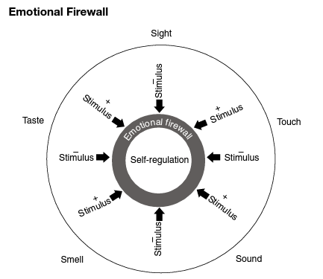
"Emotional frewall' is a method that evaluates all stimuli reaching our sensory organs and regulates them. A stimulus may trigger through senses of sight, touch, speech or smell. It filters unwanted stimulus and regulates messages going into and out of the brain.
The foundation of the 'emotional firewall' is built with the help of strong self-regulation. It insulates us from the negative stimulus, and it also helps us to manage positive stimulus effectively. It is our best insurance against emotional derailment.
Negative Emotional Clash
When interacting with people, if their negative emotions are countered with our own negative emotional reactions, it leads to conflict, sorrow, stress and anxiety for all concerned. We instinctively try to react with emotions similar to the ones we receive. This is a clear indication of the lack of self-regulation.
Once we choose to regulate our instinctive reaction and take time finding a suitable response, we deal with the situation in a better way.
When we respond with a negative reaction, the outcome is invariably not positive. It can lead to many challenging situations in our lives.
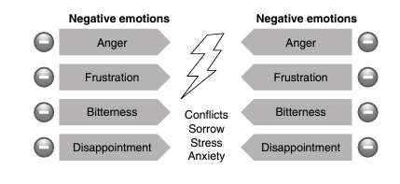
Positive Emotions Counter
When we learn to respond with positive emotion, when faced with a negative one, it changes the whole perspective. This type of response has the propensity to change the source emotion itself in others. We often prescribe this to employees dealing directly with customers in organizations.
When interacting with an angry customer, the recommendation has always been to be calm and respectful. Despite the customer venting all negative emotions, the rule book seeks us to remain calm, apologize and try to solve the problem.
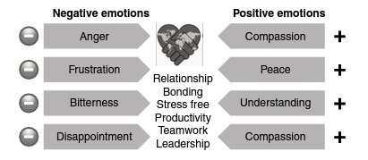
In most instances, the customer calms down after a few minutes, provided the positive emotion is displayed by the employee. The method in action is to counteract the negative emotion with a positive reaction, After a while, the negative emotion gradually neutralizes.
There is a lot at stake while dealing with customers; hence, we are compelled to respond in this manner. Imagine we extend this to other human interactions.
Another effective option in managing negative emotions is to ignore, postpone or regulate our responses. Anger is an emotion that is bound to be triggered under challenging situations. Through effective self-regulation, we can choose to express our anger at the right time, for the right cause, at the right person.
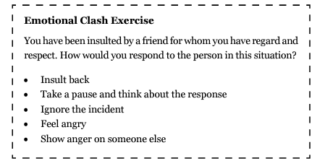
Re-scripting Our Thoughts
The essential part of self-regulation is about re-scripting our thoughts when faced with a negative stimulus in particular. The regulation process commences with identifying emotions and feelings being experienced (self-awareness) and overcoming emotional barriers to reframe thoughts, leading to a completely different set of actions.
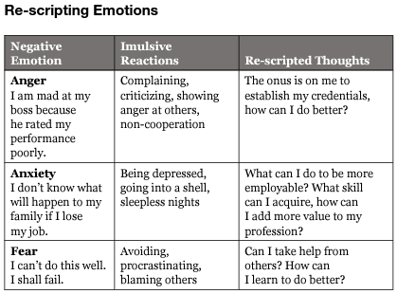
Postponement of Instant Gratification
A significant study was conducted by psychologists Walter Mischel and Ebbe B. Ebbesen. Children were offered a choice between instant rewards against additional reward if they waited for a while. The reward placed in front of them was a marshmallow sweet. Children between the ages of 4 and 6 were made to sit in a room all alone as part of this experiment.
Participants displayed various self-invented distractions. Some would cover their eyes, others would look away or kick the desk. They were all trying to resist the impulse of consuming the marshmallow.
Some children succumbed to the temptation and consumed the marshmallow without waiting.
A follow-up study was conducted 20 years later. It was found that children who waited for a while to get higher rewards performed better in all walks of life as compared to those who could not resist the temptation. Children who waited were socially more competent, self-assertive, managed difficult situations better and had the ability to postpone instant gratification, hence more goal-oriented.
It was concluded that there is a distinct relationship between the postponement of instant gratification and success in life. This stems out of selt-regulation.
Self-regulation, as a component of El, was not very popular when this experiment was conducted. This does not prevent us from attributing this experiment to highlight its importance. Impulsive and impetuous behaviour goes against self-regulation. In the past, celluloid characters in popular movies were showcased as angry young men who threw their fists at the slightest temptation and wore their emotions up their sleeves. These characters made a lasting impact in the minds of the audience, and the gate-crashing heroes were role models for many young people. This behaviour is however not tenable in our professional and personal lives.
Postponement of an emotional response is often seen as a sign of weakness. When we hear about successful achievers in any profession, be it sports, business or fine art, the common mantra for success is hard work, focus, dedication, commitment and sacrifice.
These traits are a reflection of effective self-regulation. The ability to avoid distracting thoughts and to lay focus on the goal is of paramount importance to reach the pinnacle of success.
It is important to train children at a young age on self-regulation as the absence of it would have a lifelong impact on their effectiveness.
Parents need to realize the difference between bribing the child for acting in a particular manner and teaching the child about the benefit of the pastponement of instant gratification in order to gain long-term joy and happiness.
Competition Not Good
PayPal co-founder turned investor Peter Thiel encourages people not to compete in his book Zero to One. Throughout our lives, it's been drilled into us that in order to succeed, you need to compete.
The other paradigm that will help us get ahead of the pack is to create something new, tread the untrodden path and carve our own space, different from that of competition. By competing, we could get marginally better but by creating our own space, we could be miles ahead and roox more effective. This profound thought is not only confined to organizational strategy to manage competition but also applies to individuals. From our formative age, we are not encouraged to be creative and to script our own path.
Particularly while dealing with negative stimulus, the common tendency is to compete and confront. The other option is to receive the stimulus, to be aware of the emotions we are experiencing through self-awareness and regularization. Create a unique path rather than dispensing emotions through competing. This is an innovative way to channelize our emotions.
If we compete, we have a good chance of losing, as we could well be competing with the ordinary. At times, people lower your level to match theirs and beat you at their game. Hence, the choice is to elevate yourself to a higher plane to neutralize competition.
Self-control and regulation are controlled by different parts of the brain. Self-control is housed in the medial prefrontal cortex. This is the last part of the brain to develop. Self-control fully develops only by the age of 20-24 years. Self-regulation is what makes self-control possible.
Self-regulation is a mechanism housed in the primitive part of the human brain called hypothalamus. This 15 million-year-old part of the brain controls self-regulation of five domains, namely biological, stress management, emotional, cognitive and social.
The human brain can be divided into three distinct parts:
* New brain: Neocortex, 200,000-300,000 years old.
Mammalian brain: Responsible for emotions, care for young ones, amygdala forms this part of the brain.
Reptilian brain: Designed to deal with danger, the human brain alarm system which is never turned off.
Emotional Agility
We normally tend to speak around 16,000 words a day, and we can well imagine the number of unspoken words in our minds.
Unspoken words could be either positive or negative. Many of them are entangled with emotions and cannat be openly expressed.
Self-defeating thoughts, for example, could be 'I am not well prepared for this presentation," I shall be able to achieve the targets, but my boss is incompetent or I shall not be able to grow in this company." The basic human instinct tends to lead us towards negative thoughts.
It is natural and nothing unusual. Thoughts laced with criticism, fear and doubt can occur in any healthy mind.
The difference is that effective people do not succumb to or try to suppress their inner thoughts. Instead, they deal with their thoughts in a conscious, value-based, productive manner, which is called emotional agility. In this modern, complex world, it is essential to manage one's thoughts and feelings effectively. Emotional agility helps us to manage stress, minimize challenges and be more creative, which in turn leads to better performance in all walks of life.
This is a critical skill we need to build, Developed from "Acceptance and Commitment Therapy offered by psychologist Dr Steven C.
Hayes, this skill is designed to recognize patterns, label thoughts and emotions, accept them and act in accordance with our values.
It takes constant practice to be aware and take charge of our emotional responses. Managing emotional responses has three major steps:
- Being aware of the emotions
- Understanding the emotions
- Modifying the responses
In the book Thinking, Fast and Slow by Daniel Kahneman, thinking process is divided into two kinds:
- Fast, emotional and intuitive
- Slow, deliberate and logical
Fast, emotional and intuitive thinking has great value under many situations, such as answering questions in an examination in a time-bound manner. However, in situations where emotions are involved, this may be counterproductive. It might be necessary to slow down the thought process, providing time for our responses to reshape our judgement and re-evaluate our thinking.
The process of slowing down does not mean that we delay our responses for a prolonged period of time. The idea is to take time for accepting our emotions and slow down or postpone our reactions.
This process gives us the ability to choose a more considered response, rather than rushing with an intuitive reaction.
The human brain has the ability to take account of our experiences and provide an effective response. This can happen only if we allow it by slowing down our responses in emotionally charged situations.
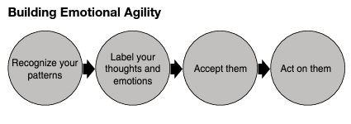
There are four steps to building emotional agility, namely recognizing patterns, labelling thoughts and emotions, accepting them and acting on values.
Recognize Your Patterns
The first step is to recognize that we are hooked to certain sets of thoughts and feelings. This is challenging, as we could be completely unaware of being imprisoned by them.
One of the major symptoms that help us recognize patterns of thoughts is repetitiveness. These thought patterns return time and again, and eventually become rigid. Thoughts take us back to our experiences, which in turn get stuck in our minds. We must learn how to recognize repetitive thoughts in order to overcome them.
Example: Ganesh failed a few times in his mathematics exam, and his teacher labelled him 'dumb?. When he grew up, he always carried the thought that he can never be good in analytics, for he continued to recall his failure and the remark by his teacher was stuck in his mind. This affected him deeply and he avoided any assignment that D involved analytics in his career. He firmly believed that he is not competent enough in this field.
During his school days, he did not enjoy mathematics, as he had no one to coach him on the subject. His teacher's remarks remained as a repetitive thought in his mind, even though he eventually gained a good amount of experience in analytics. The lingering thought that he is not good enough on the subject remained in his mind till he recognized the pattern with a lot of effort.
Label Your Thoughts and Emotions
The act of labelling is simple, nothing but calling 'spade a spade".
Tag the thought as an emotion experienced. For example, I have not achieved professional success that I deserve is the thought resonating frequently in our minds. If so, label this thought. It allows you to observe the thoughts and feelings as they are.
Humans possess the ability to have a bird's eye view of their experiences. Simple mindfulness practice not only helps us overcome these emotions but also makes changes in the brain's cellular level circuitry. In other words, mindfulness helps in rewiring our brain for a new set of thoughts that, in turn, leads to a changed behaviour. If done effectively, negative thoughts would be seen as a passing cloud rather than being fixed and repetitive.
Accept Them
The key is accepting the fact that negative thoughts exist in our minds. They are but natural and occur to everyone. Listen to the thoughts carefully rather than rejecting, hiding, getting upset or being depressed by them. Realize that there are some hidden meanings and messages to these thoughts.
If we take 10 deep breaths, the problem might not be resolved but we would see them in a different perspective. The thought could rather change to 'I have not achieved success professionally as much as I deserve, so what can I do to correct this situation, what are the things in my control I can work upon?' There is a paradigm shift in the thinking process. From a self-defeatist space, our thoughts are redirected to a constructive and positive route. If we fail to work on our negative thoughts, it could be a major dampener throughout our lives.
Act on Your Values
When we intentionally detach ourselves from negative thoughts and emotions, we can expand our choices. We can choose to align ourselves with our values to avoid treading on an unrighteous path.
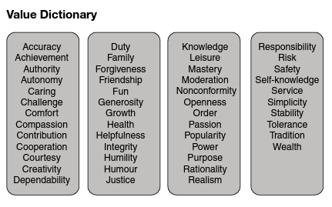
In the same example of I have not achieved success professionally as much as I deserve,' one could use unethical means to achieve success.
We run the risk of being ineffective in the long run. The stream of thought flows endlessly into our minds, and emotions change like weather, but values should be firmly rooted in us.
Value Dictionary
W. R. Miller, J. C'de Baca, D. B. Matthews and P. L. Wilbourne of the University of New Mexico drafted a list of personal popular values adopted by people. We need to question ourselves on whether we are aligned to any of these values when we make choices.
If we revisit the same example of the thought in our mind ‘I have not achieved success professionally as much as I deserve,’ we could make choices such as working honestly, taking responsibility and facing challenges posed by the job. The value at play in this instance would be ‘challenge’.
Value Filter
During the process of self-regulation, we are responding to stimulus from the environment. If the component of self-regulation is high, we tend to use the filter of our value system as we respond. With a weak self-regulation, the chances of breaching the ‘value filter’ is high.
If the stimulus is in control of our emotional responses, we are inclined to breach the value filter. In less challenging situations, we might respond on the basis of our value system, but due to lack of self-regulation, our value system is most likely to be bypassed.

